

**Project Initialization and Planning Phase**

|  |  |
| --- | --- |
| Date | June 2024 |
| Team ID | 739890 |
| Project Name | The Language Of Youtube: A Text Classification Approach To Video Descriptions |
| Maximum Marks | 3 Marks |

**Define Problem Statements(Customer Problem Statement Template):**

The business problem in this scenario is to help clients identify the appropriate category of YouTube videos to advertise their product based on the text descriptions of the videos. This is a challenging task since YouTube has a vast collection of videos covering different topics and categories, and it can be difficult for clients to identify which category of videos will be the most effective for advertising their product. By developing a text classification model based on NLP and deploying it using Flask, this project aims to provide clients with a tool to make more informed decisions about where to advertise their products on YouTube.Reference: <https://github.com/Kamya-Paliwal/The-Language-of-YouTube-A-Text-Classification-Approach-to-Video-Descriptions/blob/main/app.py>

**Example:**

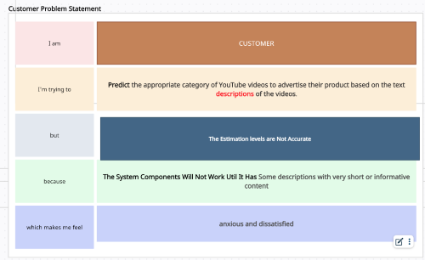





|  |  |  |  |  |  |
| --- | --- | --- | --- | --- | --- |
| **Problem**  **Statement**  **(PS)** | **I am** | **I’m trying to** | **But** | **Because** | **Which makes me**  **feel** |
| PS | **A data**  **scientist working on The Language Of Youtube: A Text Classification Approach To Video Descriptions** | **Develop a predictive model for to predict the best video category for businesses to advertise their products on YouTube** | I'm encounterin g difficulties with data quality and the complexity of Video descriptions can be in various languages, making it challenging to process them uniformly. | **the available data is often incomplete, inconsistent, and influenced by numerous unpredictable factors such as**  **Incomplete Descriptions,**  **Inconsistent Formatting** | concerned about the reliability and accuracy of the predictions, impacting the effectiveness on the Presence of spammy, irrelevant, or promotional content |